Early Bloomers
Newsletter


4TH Nov – 20TH Dec

Welcome back to Early bloomers newsletter, the festive season is here, and the year is coming to a close. Firstly, all the staff at early bloomers want to thank you all for making our club such a special and lively place.
This December has been filled with lots of festive fun, including Christmas crafts and baking that everyone has enjoyed.
It’s been a busy and fulfilling term for both the children and staff and looking forward to sharing it with you.
Highlights:
Table 1
The children have been using the multiplication square outdoors to identify and learn numbers with Sharon. Table one have been exercising their problem-solving skills and teamwork with fun puzzles. December is full of Christmas activities the children decorated wooden tree ornaments and used paints and festive stamps to make colourful holiday themed artwork.
Table 2
Table two explored textures and sensory fun with shaving foam play and sand play.
The children used snowflake stencils and paint to create beautiful winter art. Everyone helped shape and decorate salt dough ornaments using paints and glitter, adding a personal touch to their Christmas trees.
Table 3
The children focused on time by designing and making their own clocks, combining art and practical skills. Table three enjoyed some evening stargazing where children observed the night sky and enjoyed seeing and discussing the Beaver moon. The children displayed their creativity and holiday spirit by crafting holiday wreaths with holly and tinsel, some may have been turned into Christmas crowns.
Table 4
Table four experimented with different paper plane designs and tested them outside to see which flew best. The children transformed pinecones into festive tree ornaments sing tinsel and glitter. Colourful paper wreaths were crafted following instructions independently. Creating and designing Christmas cards bought some artistic talents.
Table 5:
Learning the art of paper folding the children created fun origami shapes.
Table five designed Christmas cards using tissue paper and festive stamps. The children cut and folded paper to create intricate snowflake designs embracing the winter feeling. A lively challenge where children raced to compete puzzles, fostering teamwork and quick thinking!
Reminder
Please ensure absence notifications are sent to the club phone (07763297128) by 3pm. If you send these by email, they may not reach the club in time. Emails are not monitored after 3pm which means we would have to call you to check your child has been collected.
All other matters should be sent by email to admin@earlybloomers.co.uk
Happy Holidays from all the staff at Early bloomers, we look forward to seeing you back in January!
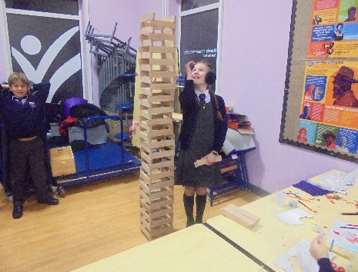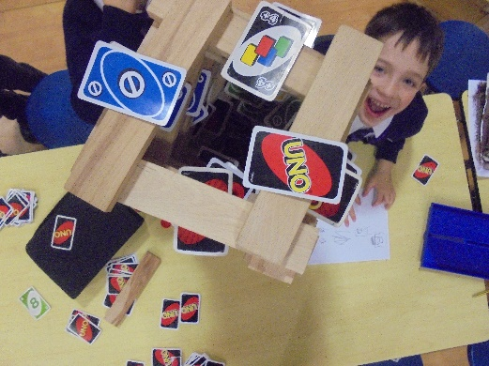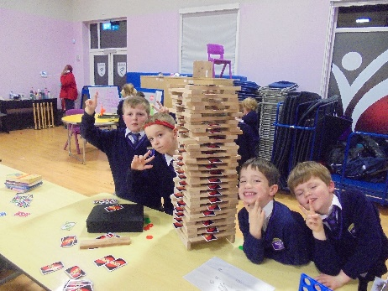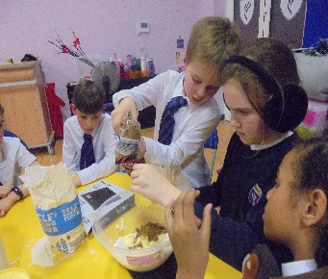
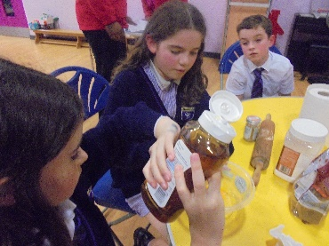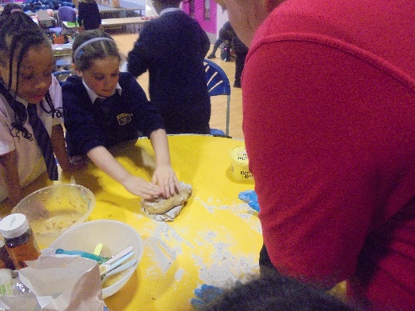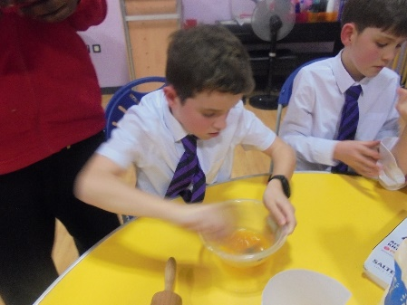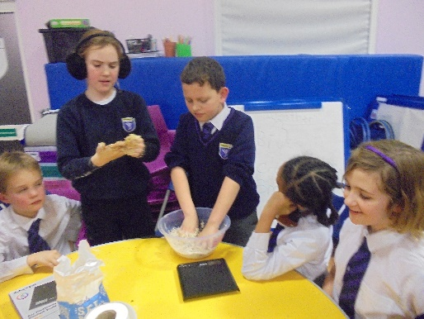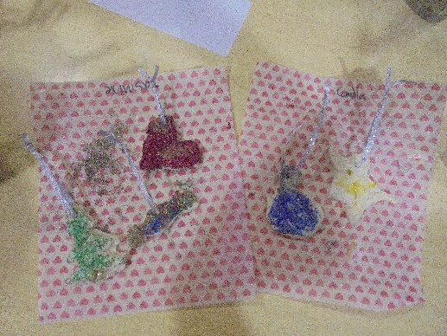
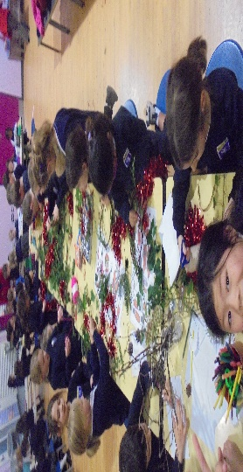Merry Christmas from Early Bloomers!

