Hello again to all our families.
What a lovely second half of term we have had,
And I’m sure we are all ready for our break over
the holiday season!
Autumn Term 2
We’ve done lots of lovely crafts and activities this term.
As a club we have joined in with World Cup celebrations. Designing kits and footballs, giving out prizes to some creative designs.
Table 4 decorated biscuits for Remembrance Day.
Everyone joined in making poppy’s and talking about what they mean.
We started celebrating Christmas with some fun activities, including Christmas slime, gingerbread making and decorating across the club.
Everyone participated in making Christmas snowflakes and baubles for the winter fair Christmas trees and decorations to bring home, including reefs, cards, and paper chains.
School start time
As School starts at 8:30, we stop serving breakfast at 8:25. If your child requires breakfast, please can you drop them off in plenty of time
Absence Notifications
When informing the club of your child’s absence please can you send a SMS message directly to the club phone on 07763297128. All other matters should continue to be sent as email

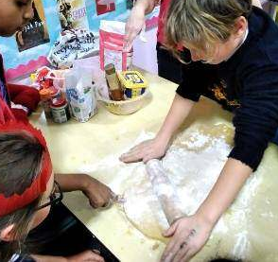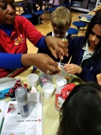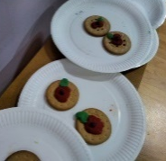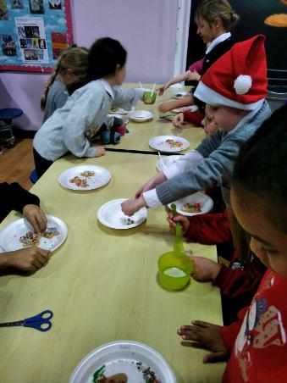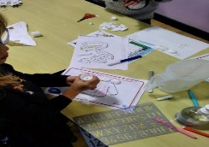

Can you guess
who this is meant to be????
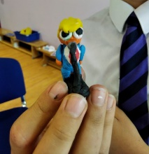

Reveal in next newsletter!!

A big thank you for all our Christmas cards and presents from everyone at EB. All the staff wish you a lovely festive beak.
Merry Christmas & Happy New year 2023!
Best Wishes, Lily

