Early Bloomers
Newsletter


19th Feb-28th Mar

Welcome back to Early Boomers newsletter, have a read of what your children have been up to this term.
Farewell to Jerry, our chess coach.
Were saying goodbye to Jerry. On his last day we had a tournament where parents could watch their children play. We will miss Jerry but wish him all the best and many checkmates!

Highlights
Table 1
The children on table one are always busy creating and having fun. They have made sensory bottles, using glitter and food colouring. They worked together to make clay volcanoes and set off a bicarb experiment. Everyone ended easter making some easter treats.

Table 2
The children have been having fun this term with sensory playdough, adding scents and getting creative. In the mornings some of the children have enjoyed joining the older children in some group games. The children spent the last week making easter baskets and then filling them with chocolate nests for a sweet surprise.

Table 3
Table 3 planted herbs to take home and take care of, feedback from the children is standing at some are faring better than others. Lots of discussions with the children about the upcoming solar eclipse. The children ended term by decorating biscuits with icing and chocolate eggs.

Table 4
Table four joined in the theme of science week, they explored time-telling through various fun activities, including crafting clocks and planting seeds to demonstrate what time can do. We got crafty and made egg boxes into flowers. The children explored buoyancy with a ‘can it float or not’ experiment.

Table 5
Table five used their imagination in junk modelling making some lovely fashion looks and showing them off outside. They got messy and had fun making cornflour slime. The children have really been sharpening their aim with regular games of darts.
September starters
If your younger child is due to start at Harris Primary and you are looking to book a place at the Club, please be sure to complete and return a registration form as soon as possible. You will get sibling priority however we do get full quite quickly.

Enjoy your two Easter break, and we will see you in two weeks!

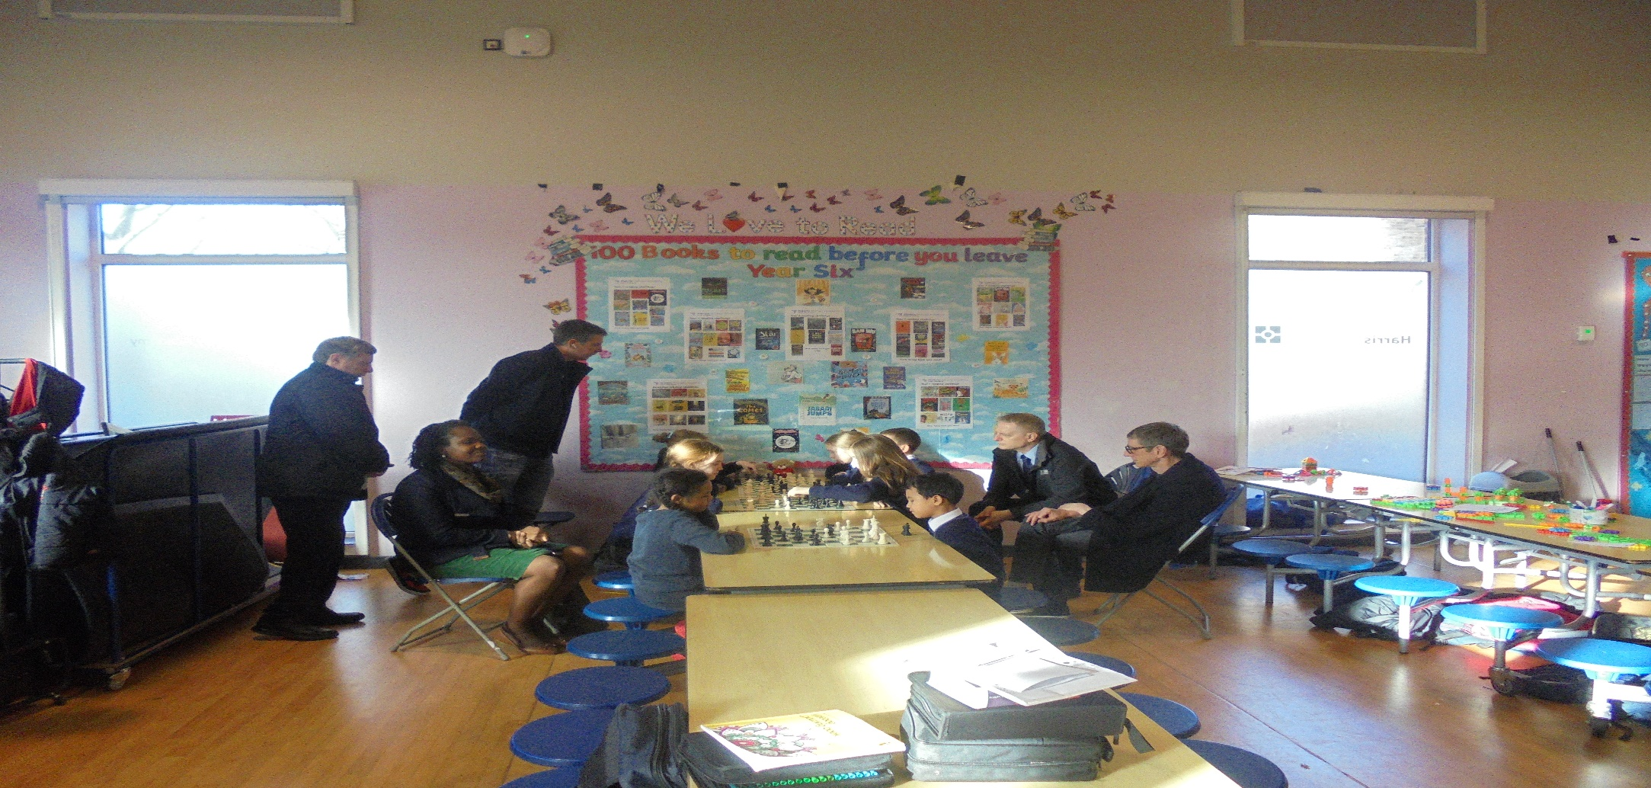

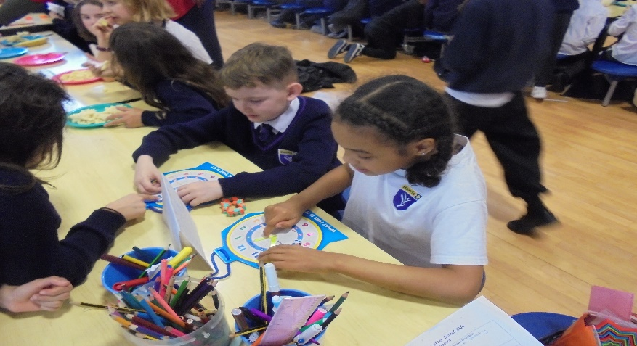
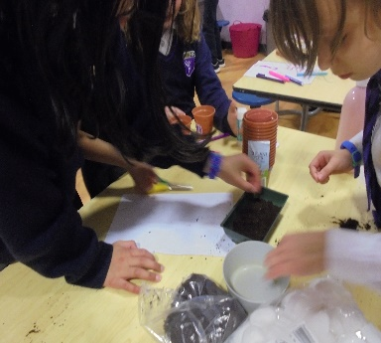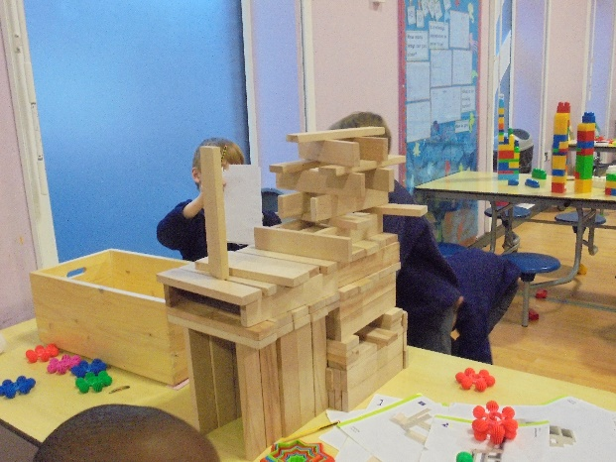
Learning to tell the time! Planting! Construction!

